**CookBook: Your Virtual Kitchen Assistant**

**Ideation Phase**

**Brainstorm & Idea Prioritization**

|  |  |
| --- | --- |
| Date | 31 January 2025 |
| Team ID | SWTID1741145782(154570) |
| Project Name | CookBook |
| Maximum Marks | 4 Marks |

**Team Details:**

|  |  |
| --- | --- |
| **Team Leader** | MADHAN KUMAR E |
| **Team member** | KEERTHIVASAN S |
| **Team member** | KRISHNAN A |
| **Team member** | MOHAN RAJ M |
| **Team member** | RAGHUL R |

**Brainstorm & Idea Prioritization Template:**

Brainstorming provides a free and open environment that encourages everyone within a team to participate in the creative thinking process that leads to problem solving. Prioritizing volume over value, out-of-the-box ideas are welcome and built upon, and all participants are encouraged to collaborate, helping each other develop a rich amount of creative solutions.

Use this template in your own brainstorming sessions so your team can unleash their imagination and start shaping concepts even if you're not sitting in the same room.

Reference: <https://www.mural.co/templates/brainstorm-and-idea-prioritization>

**Step-1: Team Gathering, Collaboration and Select the Problem Statement**

**Step-2: Brainstorm, Idea Listing and Grouping**

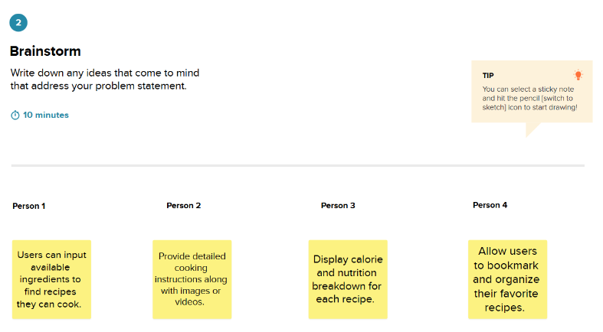

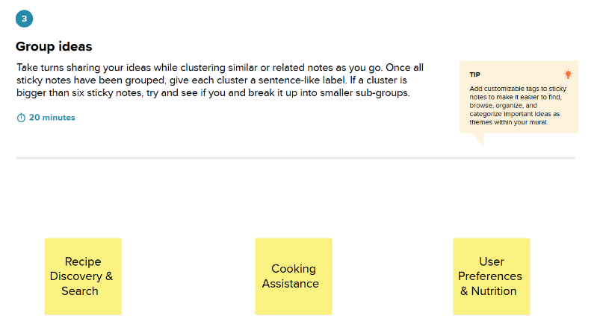

**Step-3: Idea Prioritization**

